Authorizing in the system with electronic ID cards issued by the EU memberstates
The document is prepared with expandable blocks (blocks expand and collapse by pressing on symbol), functionality available for MS Word 2013 or later (for earlier versions of MS Word, blocks are always expanded and not collapsible).

Authorizing with latvija.lv

On the left side of the EPS homepage, click on the lock symbol icon button.
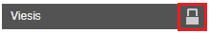

In the popup window “Authentification” click on the site “Latvija.lv”.
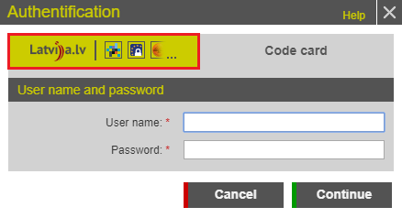

The authentication selection page of Latvija.lv opens, where you can read the terms of use of electronic identification by clicking on the hyperlink. Check the box to confirm that you have read the terms and allow the use of personal data for authentication purposes.

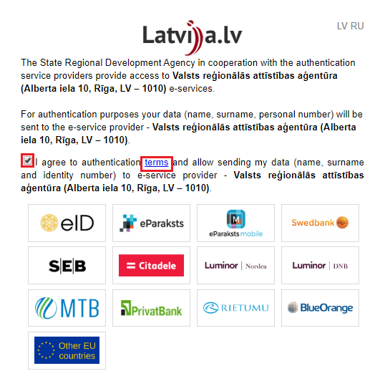

Click on the authentication tool icon “Other EU countries”.
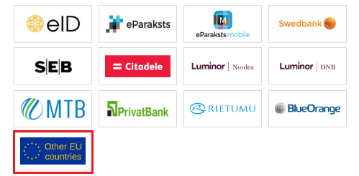

In the Authentication Tool, select the country, press the "Submit" button and perform the authentication process with your chosen national authentication tool.
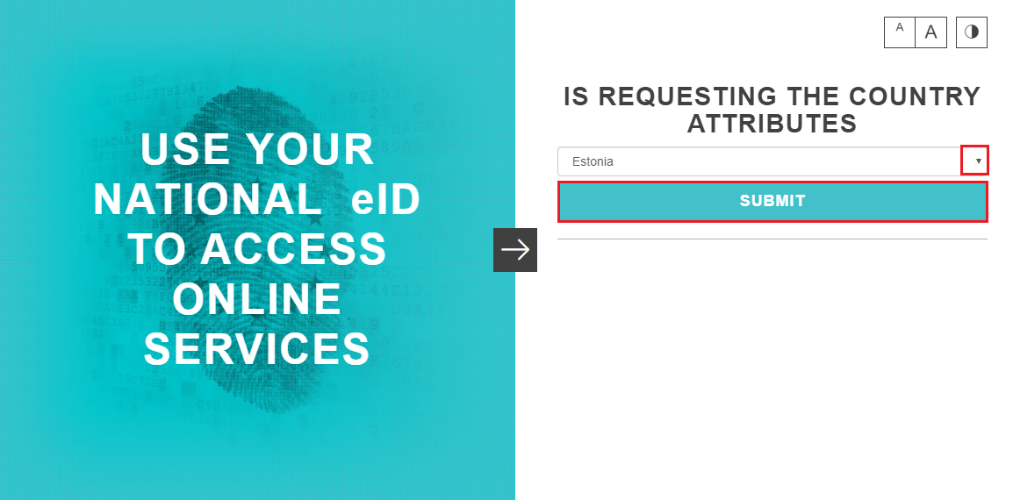

Upon successful authentication, an authentication error is received.
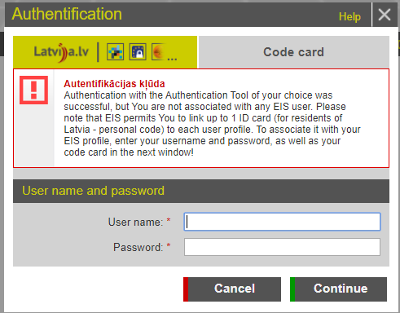

Linking the Authentication Tool to the EPS Profile

To link the authentication tool to your EPS profile, enter your username and password, then click “Continue”.
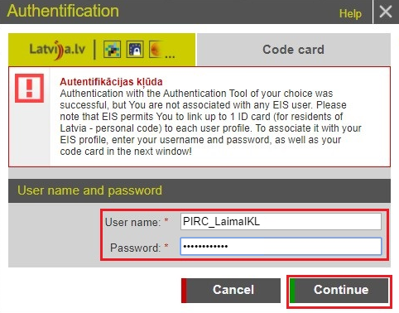

If the user name and password are entered correctly, a new input field will open. Enter the required code from the code card and press the "Enter" button.
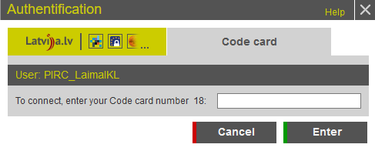

Now you can work as an authorized user in the system, who has right to authenticate with the national authentication tool of your choice.
Note that the user profile automatically reads the eIDAS identification code and adds an indication that the user can authenticate with the eIDAS.

If the user who wants to link the authentication tool to his / her EPS profile, has already filled in the personal code and it does not match the eIDAS identification code, then a system message will appear. You need to press the “Continue” button.

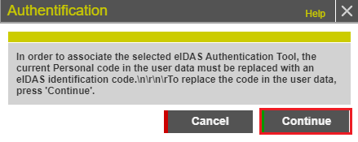

After saving the data, a system message “Data saved” is displayed to the user.
